A TIME LINE…

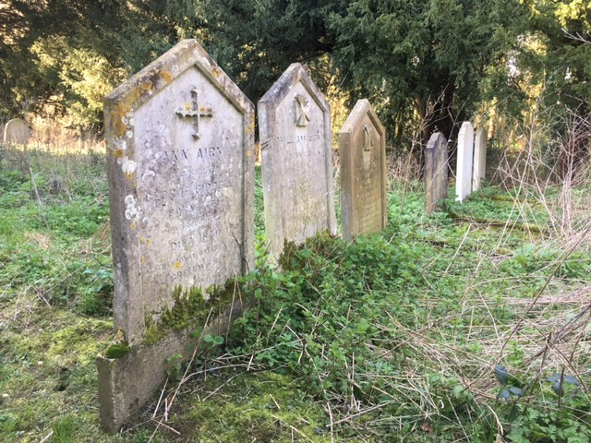
Standing at the north-east corner of St Mary Magdalen church in Little Whelnetham you can see a line of seven graves set close to each other, almost with mathematical precision, compared to other family groups in the churchyard.
I think this is not by accident.
Nearest to the church is a white gravestone dedicated to Ann Airy. It tells us she was born in Rougham, a couple of miles away, in 1767 and “died at the Royal Observatory Greenwich” in 1841.
The photograph shows six headstones. The missing one suffered a breakage, I’m told, when tree surgeons allowed a heavy yew branch to fall and break it. The two parts of the headstone now rest against the east wall of the church.
Photo; author’s own.
She is buried next to her husband William Airy. And next to him is their daughter Elizabeth who, we are told, was “For Forty years resident of the Royal Observatory Greenwich”.
How, I ask myself did these two ladies have such a connection to the Greenwich Observatory? And why buried here in the Suffolk countryside?

The next two graves belong to Ann’s sister Elizabeth Blencowe and her husband John Blencowe. (Elizabeth’s headstone is the missing one.) The last two in the family group are Elizabeth and John’s daughters Jane and her sister Lucy, who both died unmarried aged 66yrs and 64 yrs respectively.
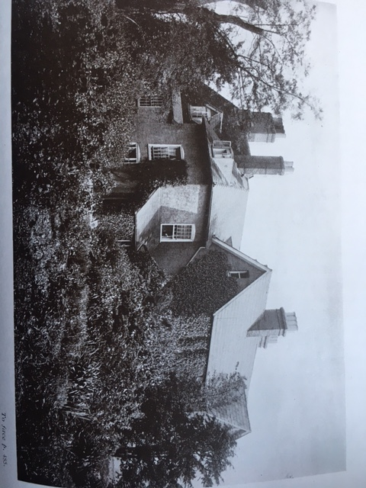
Ann Airy was born Ann Biddell. Her father George Biddell was a tenant farmer who worked for a number of years in Rougham before moving to Little Whelnetham Hall sometime around 1780.We know this because Ann’s youngest brother Arthur was baptised in the adjacent church in 1783. More of him later.
Ann would have been about 13 yrs when the family moved here, so she spent most of her teenage years here and until she eventually married at the age of 33yrs.
Little Whelnetham Hall, viewed from the north, circa 1900 (much as it appears today).
Taken from Suffolk Green Books (no. XV) 1910

William Airy was also born into a farming family, in Luddington, north Lincolnshire,
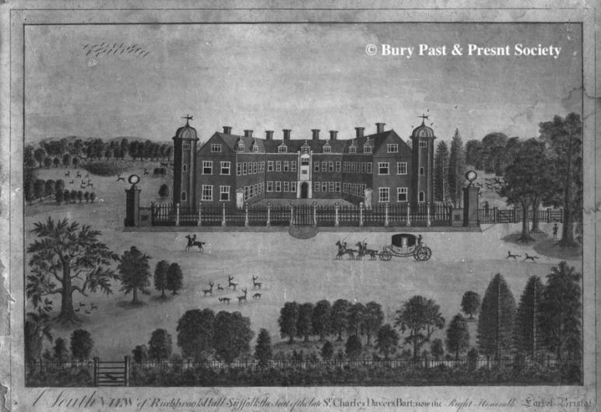
close to the Humber estuary. In his early twenties he decided to break away from farming. He entered the Civil Service and became an ‘excise officer’, (that’s tax collector to you and me!)
It was the practice then for excise officers to apply for posts around the country.
I envisage William coming to Bury St Edmunds to assess properties here for tax due on their land and buildings.
Perhaps he visited Rushbrooke Hall just a couple of miles south of the town. I see him discussing with Sir Charles Davers the value of his land and the window tax due on a house boasting over 50 windows.
Engraving of Rushbrooke Hall, circa 1810.
During WWII it was used by the Red Cross as a convalescent home for wounded soldiers.
The hall was destroyed by fire in 1961, and not rebuilt.
Photo courtesy of Bury Past & Present Society

It would be sensible to take a ride another mile to the south and visit George Biddell at Little Whelnetham Hall to assess his liabilities.
Might William have known that Biddell had three unmarried daughters? (All very Jane Austen)

Whatever the circumstances William Airy married Ann Biddell in Little Whelnetham church on the 30th September 1800. He was 50 years old, she 33yrs. The occasion would have been tinged with sadness as her father had died the previous December.

William had accepted a post in Alnwick, Northumberland in August, and so the couple moved north immediately following the wedding. In July the following year their first son was born. He was baptised George Biddell Airy, named quite obviously after Ann’s father.
Very soon William was on the move again accepting a post in Hereford. Here three further children were born: Elizabeth (1803), William (1807) and Arthur (1810).
Arthur would die aged just 3 yrs, by which time the family had moved to Colchester.

This narrative now turns its attention to George Biddell Airy, the oldest son, hereafter referred to as GBA. He excelled at school and was good enough to be accepted into the Royal Grammar School in Colchester, (1814).
He was introduced to Ann’s youngest brother Arthur (aforementioned) who had a farm in Playford just to the north of Ipswich. Arthur was a bit of a polymath, interested in the sciences and the arts. GBA and Arthur liked each other and GBA would visit his uncle whenever he could especially during the school holidays.
One of Arthur’s neighbours was Thomas Clarkson, well known for his efforts to bring the slave trade to an end. But he was a graduate mathematician, and he recognised GBA’s great talent and potential. It was the efforts of Biddell and Clarkson that GBA was accepted into Trinity College, Cambridge to study Mathematics in 1819.
Wikipedia has a good account of GBA and his achievements. He excelled at Cambridge and graduated as Senior Wrangler, the Mathematics student with the highest marks in finals. He was elected a Fellow of Trinity and 2 years later appointed Lucasian Professor of Mathematics a post previously held by Isaac Newton, and subsequently by Charles Babbage and Stephen Hawking. GBA turned his attention to astronomy and in 1828 he was apppointed Professor of Astronomy and made director of the new Cambridge Observatory.

In the same year that GBA entered Trinity College his father left the Excise Service under mysterious circumstances, and he moved his family to Bury St Edmunds.
I consulted GBA’s autobiography for more detail, but found none. I did find however that his younger brother William attended the King Edward VI grammar school in Bury and the Head teacher there Dr. B.H.Malkin, anotherTrinity graduate, was able to get William accepted into the same Cambridge college. He would study Divinity and become a clergyman.
The autobiography also tells us GBA visited his family in Bury 3 or 4 times a year, travelling by coach, but sometimes walking the whole distance, (ca.25 miles)
GBA and his brother William came from Cambridge to attend the funeral of his father on 31st March 1827. His autobiography makes no comment about his father, in contrast to the death of his uncle Arthur Biddell in 1860, of whom he said “He had been in many respects more than a father to me; I cannot express how much I owed to him, especially in my youth.”

In 1824 GBA and his brother William took a walking holiday into the Peak District in Derbyshire. GBA carried with him a letter of introduction to the Rev. Richard Smith (yet another Trinity graduate and former Fellow) who, as well as being parish priest in Edensor, was also chaplain to the Duke of Devonshire at Chatsworth House.
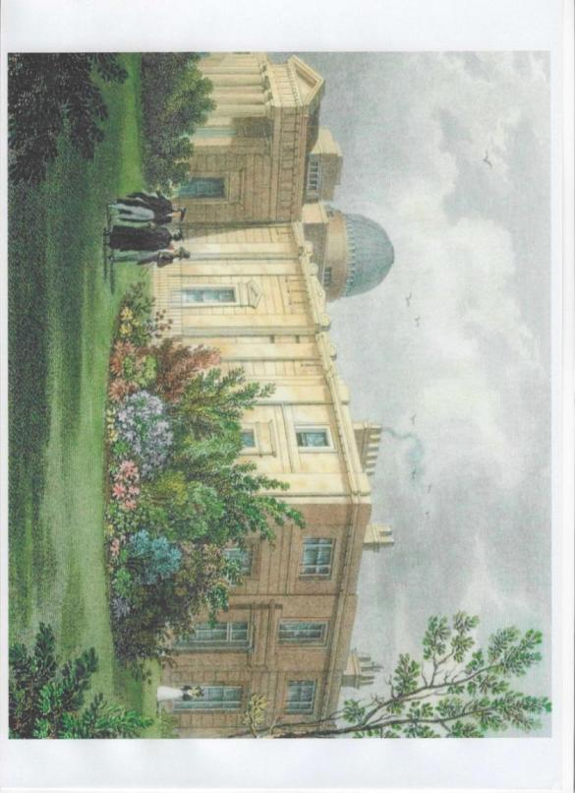
GBA was immediately smitten with one of the reverend’s 6 daughters, Richarda.
Within two days, it is said, he proposed marriage, but father was having none of it. Here was a university student with not a penny to his name, and not in employment; “Come back when you have prospects” was the message.
It was 6 years later when GBA had been appointed Director of the Cambridge Observatory that Richarda was allowed to accept his proposal. They were married in Edensor church on the 24th March 1830. Her father officiated at the wedding, of course.
A painting, possibly by J & H.S.Storer, of the new Cambridge Observatory completed in 1825.(Public domain via CC BY 4.0) The building is much as GBA would have known it.
Is that Richarda at extreme right of picture?

In 1828 after the death of her husband Ann Airy moved from Bury to live with GBA at the Cambridge Observatory, where he was director. GBA’s sister Elizabeth came too.
In 1830, in order to make way for GBA’s new wife Richarda, Ann and ELizabeth removed themselves to Luck’s Farm in Playford, owned by Ann’s brother Arthur. In due course GBA would buy a cottage there in Church Lane.

GBA became Astronomer Royal at the end of 1835 and took up his post at the Royal Observatory, Greenwich along with Richarda and their 3 children George, Elizabeth and Arthur (names with which we are already familiar).
Ann died there in 1841. She is buried next to her husband in Little Whelnetham. I think it is likely her body was transported here by horse drawn hearse, a distance of approximately 80 miles.
His sister Elizabeth returned to the family which now had 4 children in the house. There should have been 6 children but sadly the first two boys to be born both died with scarlet fever within a week of each other in 1839. They are buried at Playford.
Elizabeth died in 1875, and followed her mother back to Little Whelnetham to be buried after ‘ …forty years resident of the Royal Observatory Greenwich.’
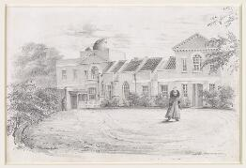
George Biddell Airy was Astronomer Royal for 45 years. Readers can research Wikipedia for a potted history of his life or refer to his autobiography as edited by his son Wilfrid.
He was an extremely clever man, well versed in mathematics and the sciences, astronomy, the classics, history. His output was prodigious.
For me, three or four episodes typify his breadth of knowledge and influence.
Pencil drawing of GBA crossing the Front Court of the Royal Observatory, Greenwich. It is dated 1839 and is drawn by Elizabeth Smith, one of his sisters-in-law. (Public domain via Univ. of Cambridge Digital Library.)

He devised a method of correcting the deviation of a magnetic compass produced by the iron in ships.
He determined the mean density of the earth using pendulum experiments. (His result was an underestimate; in error by about 20%)
He was part of the commission which decided the gauge of our railway system from several which were in use, so the country has one common gauge.
He suggested to Prime Minister Gladstone that the country should adopt decimal currency. (Didn’t happen!)
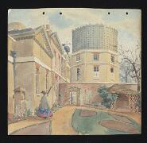
Most importantly, to my mind, as a result of being a member of the Longitude Board he established the Prime Meridian at Greenwich (1851). In 1884 at a conference in Washington D.C. attended by delegates from 26 countries it was agreed the Greenwich meridian would be observed world-wide as the prime meridian for time and longitude*.
Watercolour painting by Christabel Airy, GBA’s daughter, dated 1863, showing the newly built South East Drum Dome designed by GBA. Within it a Great Equatorial Telescope was installed, supervised by George Arthur Biddell, a cousin of GBA who worked for Ransomes of Ipswich. The dome was replaced in 1893 with the onion dome that can be seen today. (Univ.of Cambridge Digital Library)

GBA was also interested in promoting science beyond the walls of academia and I will mention just two of his public events here.
On 5 consecutive evenings in March 1848 GBA came to the Temperance Hall in Ipswich to give a series of lectures on Astronomy, which was becoming a popular pursuit among Victorian middle and upper classes.
(A full account of these lectures can be found on the website of the Orwell Astronomical Society)
Between 1870-74 the Orwell Observatory was built as an extension to Orwell Park Mansion, paid for by the owner and philanthropist George Tomline. Wilfrid Airy was engaged to advise on all the technical aspects of the build.

In October 1858 GBA gave a single evening lecture at the Athenaeum in Bury St Edmunds. Some members of the audience were so inspired by the talk that they resolved to build an observatory in Bury. Within a year they had secured enough funds to build an observatory on top of the Athenaeum roof. The original structure and telescope are still in place, but unfortunately not currently open to the public.
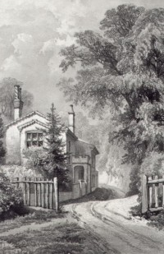
Playford became a retreat for GBA and his family and he would visit 3 or 4 times a year and always around Christmas and the New Year.

At St Mary’s church Playford, immediately opposite their cottage, is the family burial plot. As mentioned previously GBA’s two first born boys tragically died young, George aged 8yrs and Arthur aged 5 yrs, and are buried here.
Next to them lies Elizabeth, the oldest daughter, who died shortly after returning from a visit to Madeira, aged just 19 yrs (1852), “….my most dear, amiable, clever daughter” he recorded.
The headstones have weathered a great deal and my photographs are not good enough to present here.
These three children pre-deceased their parents.
A sketch by Richarda of the Airy’s cottage in Church Lane, Playford (courtesy of Suffolk Artists website).The cottage is still recognisable today.
Next in line is a double grave containing the two unmarried daughters Christabel (1842-1917) and Annot (1843-1924)). The headstone says they both died at the White House, Greenwich which was their father’s home after he had retired from his post as Astronomer Royal.
They continued to live there after his death in 1892.

His other children Wilfrid, Hubert, Hilda (Routh) and Osmund are buried elsewhere.

Completing the family group at Playford is a headstone for Richarda Airy, died before her husband and so his name appears beneath hers. For such a prominent man it is a very humble record of a life of service to his country.

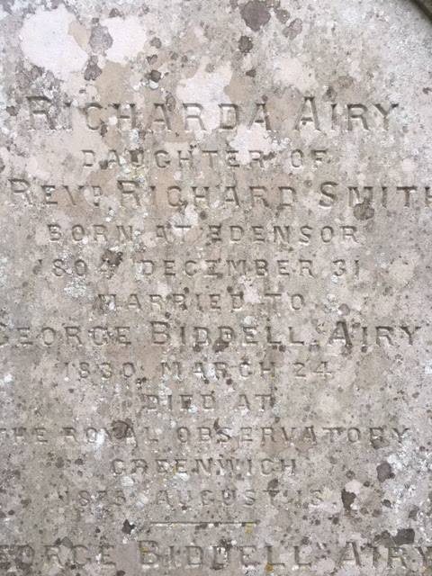
Inside the church, however, is a marble bust of Sir George Biddell Airy (knighted in 1872), mounted on the north wall, facing you as you enter.

The graves here, as at Little Whelnetham, are close together and in a perfect line; all very mathematical, aligned north-south parallel to the zero meridian, that enduring time line…
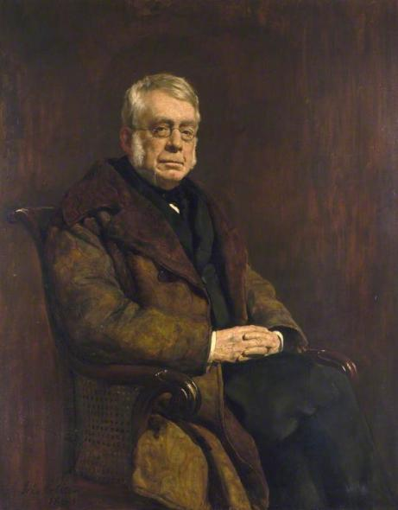
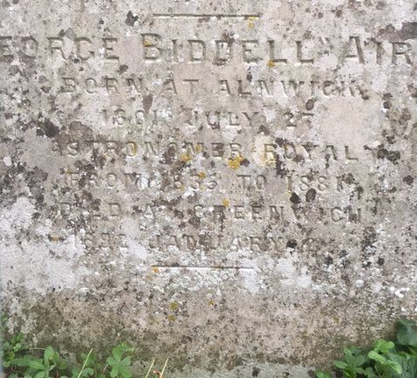

A composite photo of Richarda and George’s gravestone at Playford.
The dates are engraved in ‘astronomical style’, i.e. Year/month/day.
Photo author’s own.
Sir George Biddell Airy as painted in 1883, after retiring as Astronomer Royal. (National Maritme Museum, Greenwich, London. Airy Collection.)

*Satellite technology has given us a more exact
position for the Greenwich Meridian so that it now lies about 100 metres east of Airy’s line.

Sources.
Wikipedia.
Findmypast.co.uk.
Bury Free Press.
Orwell Astronomical Society
Cambridge University Library
FreeBMD
Autobiogaphy of Sir George Biddell Airy.
Whelnetham Parish Registers and History (Green Books)

