**Orwell Astronomical Society (Ipswich)**

***A History Of Orwell Park Observatory***

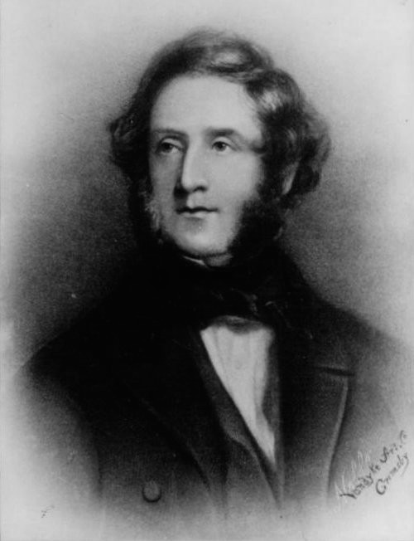

*Colonel George Tomline (1813–89), who commissioned Orwell Park Observatory in the early 1870s.*

**Contents**

1 Admiral Edward Vernon And His Descendants 1

2 Colonel George Tomline 5

3 Construction Of Orwell Park Observatory 11

3.1 Tomline Refractor 14

3.2 Transit Telescope 18

4 John Isaac Plummer 20

5 The Pretyman Family 24

6 Orwell Park School And World War II 27

7 Ipswich And District Astronomy Society (IDAS) 28

8 Orwell Astronomical Society, Ipswich (OASI) 29

8.1 Renovation Of The Observatory 29

8.2 Open Days 34

8.3 Organisation And Members 36

8.4 Chairmen 36

8.5 Tomline Refractor 37

8.6 Observations 38

8.7 Other Activities 41

9 The Future of Orwell Park Observatory 43

10 References 44

11 Document History 46

Contact OASI for further information on any of the matters in this booklet: web [www.oasi.org.uk](http://www.oasi.org.uk), email info@oasi.org.uk.

# Admiral Edward Vernon And His Descendants

First to occupy a house at Orwell Park was Admiral Edward Vernon (1684–1757), who lived there between approximately 1727 and his death. It is not known whether he purchased a pre-existing house, or built a new one.

Vernon was born on 12 November 1684 in Westminster, London. He attended Westminster School and went on to join the Navy on 10 May 1700 as a volunteer aboard HMS *Shrewsbury*. On 16 September 1702, he was promoted to lieutenant aboard HMS *Lennox*. On 22 January 1706, he was promoted to captain and took command of HMS *Dolphin*. However, he was transferred just 10 days later to HMS *Rye*, which he commanded for almost two years, before transferring again to HMS *Jersey*. For the next 14 years, he served aboard several ships, mainly in the West Indies and Baltic. In 1721, he was reduced to half pay for a period of five years when his ship at the time, HMS *Mary*, was withdrawn from active service.

During his time on naval half pay, in 1722, he entered Parliament. He represented at various times the constituencies of Dunwich, Penryn and Ipswich. His main contribution to parliamentary debate was with regard to naval matters and he generally supported the Whigs.

On 15 July 1729, he married Sarah Best, daughter of Thomas Best, a brewer from Chatham, home to the Royal Naval Dockyard. They had three children, all boys, all of whom died young.

Vernon was famous for sea campaigns against the French and Spanish in the mid-18th century, during the so-called *War of Jenkins’ Ear[1]*. He accomplished his most audacious exploit near the beginning of the war when, on 21 November 1739, with a force of only six ships, he captured the heavily fortified port city of Porto Bello in Panama. Remnants of the battle, including cannon and broken down fortifications, are still visible.

When news of the victory reached England nearly four months later, there were huge celebrations! Vernon was granted the Freedom of the City of London, medals were struck in his honour, and public houses and first-born sons were named after him. Vernon Street, close to Ipswich Docks, was named in his honour. A farmer in London changed the name of his farm to Porto Bello: this later became Portobello Road in Notting Hill. The first public performance of *Rule Britannia* by Thomas Arne was given in celebration of Vernon’s heroism.

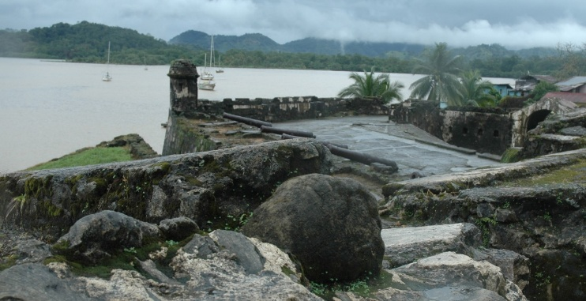

*Remains of fort at Porto Bello.*

Life at sea in Vernon’s era was very hard. Drunkenness aboard ship was endemic, fuelled by the rum ration. Vernon was concerned about the treatment of his men at sea and, in 1740, in order to curtail drunkenness, issued an order to dilute the rum ration aboard his fleet to one part rum to three parts water. Vernon’s nickname was *Old Grog*, after his cloaks, which were spun of a fabric called grogram (a very hard-wearing mix of silk, wool and mohair), and the sailors coined the term *grog* to describe the watered-down rum: this is the origin of the words *grog* and *groggy*.

Vernon’s next major campaign after Porto Bello was a massive amphibious military engagement against the Spanish city of Cartagena in modern-day Colombia. The city was heavily fortified and under the control of a particularly tenacious Spanish commander, Blas de Lezo. Hostilities began on 23 March 1741, and ended two months later in disaster for the British as Vernon was forced to withdraw after suffering heavy casualties. Ultimately, the episode cost the British Prime Minister, Sir Robert Walpole, his job.

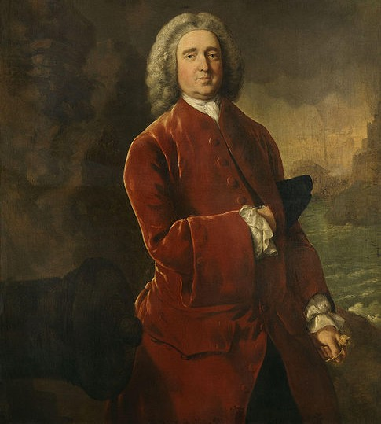

*Admiral Edward Vernon, by Gainsborough.*

George Washington’s half-brother, Lawrence Washington, served aboard Vernon’s ship as Captain of the Marines in 1741. Washington renamed the family home at Little Hunting Creek Plantation, Virginia, USA, Mount Vernon in honour of the Admiral. The town is the location of George Washington’s estate.

Although by the mid-1740s Vernon was one of the most experienced commanders in the Navy, his career was soon to end. Pamphlets of his correspondence with the Admiralty were published in 1746 under the titles *Seasonable Advice from an Honest Sailor* and *A Specimen of Naked Truth from a British Sailor*. The Admiralty obviously did not appreciate the publications, and in 1746 struck Vernon from its list of flag officers, terminating his naval career. Two years later he published a third pamphlet entitled *Original Letters to an Honest Sailor*.

On leaving the Navy, Vernon continued his parliamentary career, representing Ipswich until his death. He died on 30 October 1757 in his mansion at Orwell Park.

We know little of the owners of Orwell Park between the death of Vernon and the mid-nineteenth century, and this represents a potential area for further research. The bare facts are as follows.

Upon Vernon’s death, his cousin, Francis Vernon (1715–83), inherited the mansion. Francis rebuilt it and added an extensive deer park to the surrounding lands. He bought the title Viscount Orwell, as a result of which the lands became known as Orwell Deer Park and later simply Orwell Park. He died in 1783, leaving the estate to his nephew, John Vernon (1776–1818).

When John Vernon died, the estate passed to his sister, Arethusa (1777–1860) and her husband, Sir Robert Harland (1765–1848), who had previously lived just across the River Orwell at Wherstead Lodge. Upon Sir Robert Harland’s death, George Tomline purchased Orwell Park.

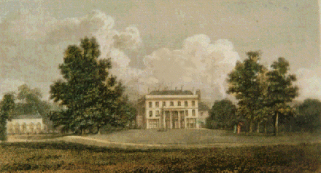

*The mansion at Orwell Park as rebuilt by Francis Vernon.*

# Colonel George Tomline

George Tomline was born in 1813 at Riby Grove Estate, near Grimsby, Lincolnshire. He was educated at Eton, where William Gladstone was among his classmates.

Tomline inherited enormous wealth from both his parents. In his 20s, upon the death of his father, he inherited his London home at the extremely fashionable and expensive address of 1 Carlton House Terrace. The house, just off The Mall, was designed by Nash. Tomline’s father had used the house while attending Parliament. Tomline based himself at the house while in London, entered London Society and, in common with most young men of his social class and wealth, undertook the Grand Tour of Europe.

Despite being a highly eligible bachelor, he never married; gossip of the day hinted that he had been let down in love. Instead, he expended his energies in civil and governmental affairs, and on science:

* Civil He was a philanthropist. He believed it was the duty of men of wealth to help the poor and, in line with this philosophy, created work for people living on his estates.
* Government Tomline was MP for Sudbury (1840–41), Shrewsbury (1841–47, 1852–68) and Great Grimsby (1868–74), but never Ipswich. He was also a magistrate, Justice of the Peace, and High Sheriff of Suffolk and Lincolnshire in 1838 and 1852 respectively. He was closely involved with Sir Robert Peel in the repeal of the Corn Laws in 1846 and, in the ensuing re-alignment in British politics, followed Peel into what later became the Liberal Party. Peel later said that the best of his young men were Tomline and Gladstone, in that order.
* Science He was keenly interested in all matters of science and engineering, and enjoyed one of the finest private libraries in the land, together with a fine art collection. He was erudite, had beautiful copperplate handwriting and could discourse knowledgeably on many subjects.

Despite his title, Tomline was not a military man. In fact, his title was an honorary one, courtesy of the Royal North Lincolnshire Militia, in which he was Lieutenant Colonel.

Although enjoying wide-ranging interests in many affairs, he was camera shy. A well-known silhouette was for many years thought to be the only image of him. However, in 2003, the editor of the Grimsby *Evening Telegraph* provided OASI with a photograph from the paper’s archives; it is reproduced on the front cover of this booklet.

Upon Sir Robert Harland’s death in 1848, Tomline bought Orwell Park. At the time, he was thought foolish to purchase the estate, as it did not have a reliable water supply (all the wells had turned brackish). However, a spring was soon located in the woods only a kilometre from the house. Tomline exploited the spring and installed filter beds, an underground reservoir and a water tower containing a 45kL tank. He arranged to pump water from the reservoir to the tank and from there to 26 smaller tanks in the roof of the mansion. Water also powered a hydraulic lift that he installed much later in his Observatory, some years after it was opened.

Tomline bought a huge amount of surrounding land so that his estates finally totalled nigh on 12,150ha, including much of the Colneis Hundred. Deeds for several members of OASI living in Ipswich show their homes to be built on land originally owned by Tomline.

Tomline had Orwell Park Mansion extensively remodelled and re-orientated with the main entrance to the north (the configuration that we know today). The work was carried out in two main phases. He initiated the first phase shortly after he bought the mansion. During the second phase, in the early 1870s, he added two guest “state” bedrooms and an observatory to the mansion (and made many other changes). Tomline’s motives in commissioning an observatory are not entirely clear. Astronomy was a very fashionable and rapidly advancing science at the time, and one in which he held a keen interest, as indeed he did in all the sciences. However, there is no evidence that he ever used the Observatory himself. His obituary in the *Lincolnshire Chronicle* suggested that his expenditure on astronomy was in line with a conscientious belief that it was *his duty to employ his money in every direction in which human activity demanded recognition and the co-operation of men of wealth*.

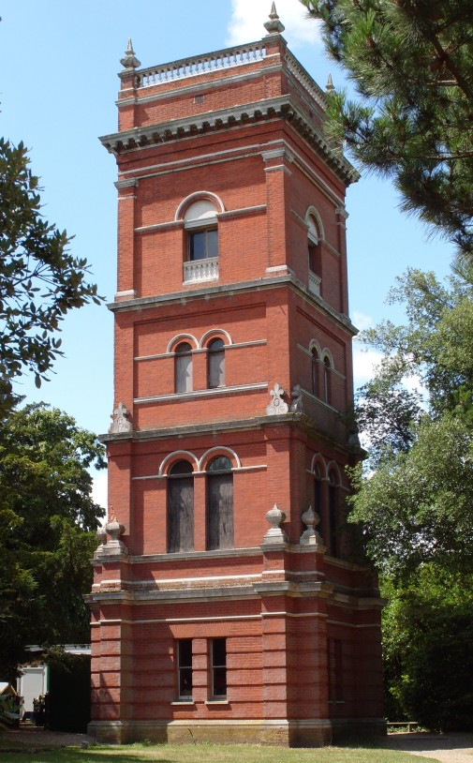

*The Water Tower at Orwell Park.*

The Observatory was built to a very high standard (details below) and although no record survives of the cost of construction, it was clearly enormous. Tomline employed John Isaac Plummer (1845–1925), a professional astronomer, to operate the facility. An account of Plummer’s life and the work that he undertook on behalf of Tomline is below.

The work on the mansion undoubtedly provided much badly needed labour for Tomline’s estate workers, and would have been very welcome during the agricultural depression of the 1870s.

Tomline’s many other projects included the construction of the Ipswich - Felixstowe railway and Felixstowe Docks.

In the early 1870s, he attempted to gain government approval for construction of an Ipswich - Felixstowe railway line. Although the scheme was generally popular locally, his neighbour, who lived at nearby Broke Hall, through whose land the line would run, thwarted several attempts. After one Ipswich - Felixstowe Railway Bill fell, local residents drew up a petition of support and collected 7000 signatures in 30 hours. By the time it was presented to Downing Street it contained 10,000 signatures and was almost 60 metres in length! Finally, in 1875, Parliament enacted the Felixstowe Railway and Pier Bill and Tomline formed the Felixstowe Railway and Pier Company to build and run the line. Branching from the main line at Westerfield, the line looped round east Ipswich and travelled south-east towards Felixstowe, serving new stations at Derby Road, Orwell, Felixstowe Beach and Felixstowe Pier. Construction of the line proceeded with considerable haste, and the first train ran on 01 May 1877. In 1879, the Great Eastern Railway took over running the line, the owning company changed its name to the Felixstowe Dock and Railway Company, and a further act of Parliament enabled the construction of docks, warehouses and additional railway infrastructure. Work started on the dock basin in 1882 and the dock opened for trade in 1886. There is a reminder of Tomline’s instrumental role in creating the railway line in Tomline Road, Ipswich, which is named after him; it is adjacent to Derby Road Station.

In Tomline’s era, the value of the pound sterling was defined in terms of a quantity of gold (the so-called *gold standard*). Tomline was an early and vigorous proponent of bimetallism, which held that the value of the currency should be defined in terms of both a quantity of gold and a quantity of silver (thus defining a fixed rate of exchange between the metals). In the early 1870s, he disputed with the Chancellor of the Exchequer over the matter in Parliament and in a lengthy correspondence in the pages of *The Times*. As part of his campaign, he sent confidential agents to generate support, amongst people transacting commercial business, for an increase in the quantity of silver coinage in circulation. To reinforce the point, he dispatched quantities of silver to the Treasury to be minted, but, unsurprisingly, the Mint refused to strike coins from the metal. The episode revealed a very disputatious side to his character, which became manifest again a few years later.

The War Office became Tomline’s next major governmental foe. A dispute, dubbed by a local paper *The Civil War*, began shortly after Tomline purchased the Manor of Walton-cum-Trimley. The War Office owned about 40ha of land adjacent to Tomline's, upon which it held a 999-year lease at a rent of £10 a year. On 06 January 1875, Tomline received a notice that the War Office offered him £100 for 81ha of his land. Tomline replied that he would be prepared to sell the land for £36,000! The War office immediately rejected his offer. An arbitration court was convened in Ipswich, in January 1876, to assess, under compulsory powers of the Defence Act, the value of the land. Tomline submitted to the arbitration court a new assessment of the value of the Manor of £40,000, including items for wreckage, seaweed, minerals and bathing machines, and he asked for an additional £22,000 for Langer Common. The jury assessed the value of Tomline's land as £11,039. Tomline refused this assessment and took the matter to appeal in the London law courts. On appeal, the value of the land was assessed as £15,000, a figure that Tomline accepted. In subsequent years, he had further legal tussles with the War Office concerning the extraction of coprolites and shingle and the water supply to Landguard Fort. Only a person with his financial resources could have entertained such disputes with a government department.

He was, however, also a very benevolent member of society, accepting many honorary positions in various local organisations, including the Royal Harwich Yacht Club of which he was Commodore 1872–76. Upon his election, he commissioned a steam screw yacht, *Gazelle*, just to travel the few kilometres to Club meetings across the river from his estate! She was a decent size, being almost 24m long and 29.5t Thames measurement.

Although Tomline did not attend to the day-to-day running of the Club, he chaired every AGM during his tenure and the minutes, in his very neat handwriting, vastly different from that of the rest of the committee, are a joy to read.

He was also founding patron of the Felixstowe Ferry Golf Club, which was constituted on 22 October 1880. He owned the land on which the links were laid out and gave his consent to the cutting of bunkers. He owned Fast End House and, when it became vacant, offered it to the Club for use as a clubhouse. The Club accepted the offer and it is still the clubhouse today.

Whilst at Orwell Park, Tomline entertained many important persons. Indeed, the future King Edward VII was a regular visitor. They often hunted together; the King and Colonel always on the same team.

Tomline died at his London home on 25 August 1889, following a stroke earlier in the year that left him hemiplegic. His funeral service was at St Martin in the Fields, in central London, followed by his cremation at Woking, at the time the only town in the country boasting a crematorium. Tomline became only the 93rd person in the country to be cremated, an option that was then considered radical. After his death, selected items were sold from his London home by auction and raised £3303, a not inconsiderable amount at the time.

# Construction Of Orwell Park Observatory

With huge wealth at his disposal, Tomline set out to create a first class observatory and spared no expense in its construction. He appointed as architect John Macvicar Anderson, later president of the Royal Institution of British Architects, and as engineer responsible for the specification of scientific instruments, Wilfrid Airy, son of the seventh Astronomer Royal, Sir George Biddell Airy. (George Airy owned a country retreat at Playford, near Ipswich, and it is very likely that Tomline knew the Airys socially.) Tomline employed Messrs George Smith & Co of London as building contractors for his Observatory.

Tomline specified that his Observatory be integral to the mansion. This was highly unusual at the time; it was customary for a wealthy Victorian to site his private observatory separate from his house, atop a low hill or rise on his land, to command a clear view of the horizon. Tomline’s specification created an interesting opportunity for Anderson and Airy. In order to hold the telescopes clear of the mists that can rise from the nearby River Orwell, Airy specified that the floor of the observing room be positioned 16m above ground level. This established the height of the Observatory Tower and its essential form as a five story edifice. He dedicated the top floor to astronomical purposes, and on the lower floors enabled Anderson to design highly desirable additional facilities for the enjoyment of Tomline and his guests:

* Basement: the steam room of a Turkish bath suite.
* Ground floor: the tepid and cool rooms of the Turkish bath suite.
* First floor: a muniment room for storing valuable documents.
* Second floor: a belvedere giving access to balconies from which to admire the lands surrounding the mansion.
* Third floor: the equatorial room and transit chamber.

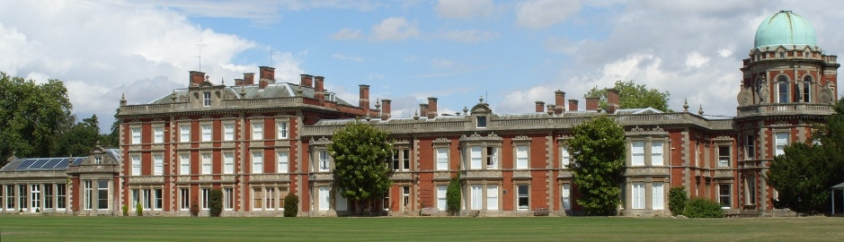

*The rear of Orwell Park Mansion, with the Observatory Tower on the east wing.*

The Observatory was equipped with a 26cm refractor (nowadays called the Tomline Refractor) mounted in the equatorial room, accompanied by a 7.5cm transit instrument and Dent sidereal clock in the transit chamber. Although the telescopes are still present and in working order, unfortunately, the clock is now missing.

In order to provide a stable mount for the Tomline Refractor, Airy specified a 16m high column, 3m wide at the base and 2m wide at the top, constructed from bricks and mortar. (He chose mortar rather than cement as the former expands and contracts less with changes in temperature.) At the top of the pillar, he placed a 30cm thick York stone to provide a firm mount for the telescope. The pillar rises centrally through the Observatory Tower. Both pillar and Observatory Tower share a common foundation in the form of a massive circular concrete base, 15m in diameter by 1.2m deep. Inside the Observatory, the pillar is surrounded by an interior wall. Thus, although the pillar and the Observatory Tower are built upon a common foundation, they are otherwise independent, isolating the refractor from vibrations generated elsewhere in the mansion.

The pillar tapers in diameter towards its top. Anderson arranged for both the exterior walls of the Observatory and the interior wall encasing the pillar to taper similarly, to yield a space 2.3m wide between the two on every floor.

The interior of the equatorial room is 6m in diameter. The Tomline Refractor is mounted in the centre, on the York stone slab at the top of the pillar. The walls of the equatorial room support a revolving dome running on 13 wheels[2] mounted in wheel-boxes inset in the wall.

The dome is built around a framework of cast iron ribs 10cm thick. The inside is lined with polished tongue and groove mahogany planks. These may have been shaped by boat-builders on the River Orwell; possibly by the builders of Tomline’s steam yacht *Gazelle*, which was built at roughly the same time. The exterior of the framework is lined with deal (softwood) and copper sheeting on the exterior. Over the years, the copper has oxidized, and now presents a green patina. The dome weighs approximately 3t.

The dome has an aperture running from base to apex. When using the facility, the observer rotates the dome so that the desired object is visible through the aperture. A toothed ring and pinion provide the means to rotate the dome. The toothed ring is set into the top of the walls of the equatorial room. A large rimmed wheel is mounted on the inside of the dome; on the axle of the wheel is mounted the pinion which engages with the toothed ring. The dome is rotated by turning the wheel. When the Observatory was commissioned, an endless loop of rope passed around the rimmed wheel to facilitate turning the latter; nowadays, the rope has been dispensed with, and observers find it more convenient to turn the wheel directly by hand.

When the dome is not in use, the aperture is closed by a shutter running on two parallel tangent rails mounted on the outside of the dome. The aperture may be opened and closed by a system of ropes.

The transit chamber is sited off the equatorial room to the northeast. It is octagonal in plan. The transit telescope is a 7.5cm refractor constrained by its mounting to view objects along the local meridian, *i.e.* the north-south line through the sky. An aperture in the roof of the transit chamber can be opened to provide visibility of a strip of the sky stretching from horizon to horizon centred on the meridian.

The Observatory was completed in early 1874. At the time, it was one of the finest (if not the finest) in private ownership in the land, and the telescope one of the 25 largest in the world[3]. Tomline must have been rightly proud of the facility, and his many house guests would no doubt have been impressed by the architectural quality of the building and the scientific facilities which it housed. The outside back cover of this booklet shows a photograph of the Observatory.

## Tomline Refractor

In its era, the Tomline Refractor and its associated mount represented an exceptionally well-crafted instrument. Troughton & Simms, leading telescope makers of the time constructed the refractor. It is made primarily from brass; however, nowadays this is not apparent as it is painted grey!

The mount of the instrument is a massive iron casting, weighing in excess of 2t. It is of an innovative equatorial design that minimises its physical size, yet provides uninterrupted views of the entire sky. The mount has the basic form of a bent cone, with its axis aligned to the axis of rotation of the Earth: this defines the polar axis of the instrument. By rotating the telescope around the polar axis, it is possible to follow the apparent motion of a body in the heavens caused by the turning of the Earth, and to keep it in the field of view. Physically, the polar axis is a large metal rod which runs through the length of the cone. At the base of the rod, in a hollow within the mount, is a large brass toothed drive wheel, into which is inlaid an inscribed silver right ascension (RA) scale[4].

At the top of the polar axis, mounted at right angles to it, is the declination axis. The telescope is fitted at one end of the declination axis, and at the other is a lead counterweight and a large declination scale, again comprising an inscribed silver inlay in a brass ring. The telescope can turn about the declination axis (its position being indicated on the declination scale) and once at the desired position may be locked in place.

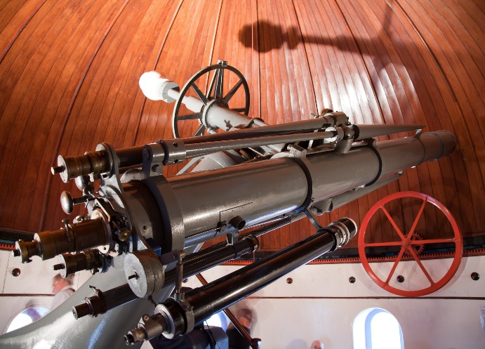

*The 26cm aperture Tomline Refractor. (The large wheel for rotating the dome is in the background.)*

Both RA and declination scales are large and fitted with Verniers, enabling the position of the telescope to be read precisely. Knobs at the eyepiece end of the telescope enable the observer to adjust the position of the instrument without taking his eye from the field of view. (Nowadays, although the declination adjustment knob continues to function, the RA adjustment knob does not.) Two periscopes are fitted to the refractor to enable the observer to view the declination scale without leaving the eyepiece end of the instrument; depending on the overall orientation of the instrument, the declination scale can be at a considerable height, and scrambling up steps to read it in the dark of the Observatory could be hazardous!

Although there is no makers’ plaque on the mount, the late Fred Dyer, historian of the Ransomes Company, visited the Observatory in May 1998 and was able to state that the mount had been cast *almost certainly* at the Orwell Foundry of Ransomes, Sims & Head (one of the many variations of the original firm and its offshoots).

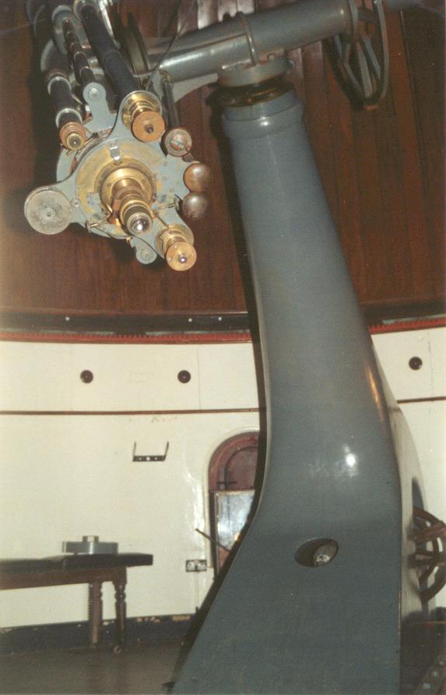

*The mount of the Tomline Refractor.*

The original drive for the refractor was powered by two heavy weights suspended in a hollow space in the walls of the Observatory. The mechanism could provide uninterrupted drive, with either weight powering the telescope while the other was being rewound. The observer could set the speed of the drive mechanism by means of a friction clutch, and a centrifugal governor mechanism ensured that the speed, once set, remained constant. The drive needed a lot of effort to wind, and in modern times has been superseded by a small electric motor.

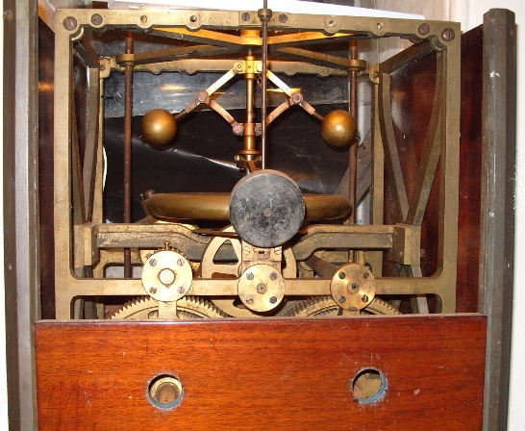

*The original drive of the Tomline Refractor.*

The refractor has a clear aperture of 26cm and a focal length of 3.9m, giving a focal ratio f15. The object glass (OG) is an achromatic doublet ground by the German optical company Merz: the flint lens was ground in 1859 and the crown lens prior to 1842 (Kost, 2014). At the time, the maximum diameter of lens that English companies could manufacture satisfactorily was about 150 mm. Airy ensured that the OG was of good quality prior to mounting it in the telescope tube at Orwell Park. He arranged for it to be mounted first in a temporary telescope tube fixed to the 33 cm aperture equatorial refractor at the Royal Greenwich Observatory (RGO), and observers then compared the performance of the two instruments, particularly in observations of bright double stars.

The refractor is equipped with a low power, 5cm aperture finder telescope. This eyepiece has a graticule to assist in centring objects in the field of view.

The eyepieces that originally accompanied the refractor have gone missing over the years. However, it may be used satisfactorily with modern eyepieces typically giving a magnification of up to 250x, and up to 500x under exceptional conditions.

Surviving documentation shows that the cost of the Tomline Refractor was £1345.68 and the OG £333.33.

## Transit Telescope

The transit telescope is mounted on two concrete piers that rise from the floor of the transit chamber. At the top of each pier is an adjustable V-shaped bearing; before use, the two bearings are adjusted to lie at exactly the same height on an E-W line. Two pivots protrude from the centre of the telescope tube and rest in the bearings. This arrangement constrains the telescope to move only in a N-S direction, up and down the meridian. The telescope is equipped with crosshairs so that it is possible to determine precisely when a particular star transits the meridian.

The observer could control, by means an ingenious mechanism, whether or not to have the crosshairs illuminated. One of the pivots of the transit telescope is hollow, with a small lens at its end. The pivots are attached to the telescope tube via a cube section in the centre of the latter. Inside the cube is a mirror, the position of which is controlled by means of a rod accessible at the eyepiece end of the telescope. The observer could position the mirror either to reflect light entering via the hollow pivot to illuminate the crosshairs, or not. A shelf built into the wall next to the east pier of the transit telescope provides a location to place a light source (a candle, in Tomline’s era).

The transit telescope was used to determine the RA of stars and to tell the time. Both uses rely on the fact that the Earth rotates with respect to the fixed stars at an essentially constant angular velocity, once every 24 hours (more precisely 23h 56m 04.09054s, a period known as the sidereal day). Effectively, the apparent rotation of the night sky may be viewed as the turning of the hands of a giant clock sweeping out one sidereal day with every revolution.

If the RA of a star is known, it is possible to determine the RA of a second star by using the transit telescope and sidereal clock to estimate the difference in sidereal time between the instants at which the stars transit the meridian. The difference in sidereal time corresponds directly to the difference in RA.

In Tomline’s era, the RGO defined the measure of civil time and published predictions of the instants when reference stars would transit the meridian at Greenwich. By the 1880’s the Ordnance Survey had undertaken accurate mapping of the UK and had established the position of Orwell Park Observatory with high accuracy[5]. It was therefore possible to establish (local) time at Orwell Park by observing a reference star transit the meridian, then consulting the predicted time for the RGO and making an allowance for the longitude of Orwell Park east of Greenwich.

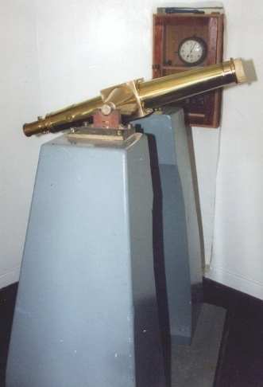

*The 7.5cm aperture transit instrument.*

# John Isaac Plummer

John Isaac Plummer was born in Deptford, London on 06 February 1845. At the time, the domes of the RGO were visible from Deptford, and this may have stimulated his interest in astronomy. Whether or not this speculation is true, he began his astronomical career as a *computer* (a person undertaking astronomical calculations) at Cambridge Observatory in 1860, moved to the RGO in 1864, to Glasgow Observatory in 1865, and to Durham Observatory in 1867. At Cambridge Observatory, he was reputed to have *a good eye for detecting faint objects*.

During his time at the four observatories, Plummer learnt the profession of an astronomer and published three papers on meteorology, 22 on astronomy and a school textbook entitled *Introduction to Astronomy For the Use of Science Classes and Elementary and Middle Class Schools*.

George Biddell Airy recommended Plummer to Tomline, and Plummer left Durham to begin work at Orwell Park in June 1874. His salary was £300 *pa* (a very handsome salary at the time and almost four times what he was paid at Durham!) plus a large tied house. The house, *Orwell Dene*, named after the land upon which it was built, lies across the valley from the Observatory on Levington Road, and boasts a magnificent view of Orwell Park Mansion. Two of Plummer’s three children were born there.

Plummer pursued a wide range of astronomical observations at Orwell Park: Venus, meteors, lunar occultations[6], lunar photography, the zodiacal light[7] and - more than anything else – comets. Of the 54 papers that he published during his tenure at Orwell Park, 48 dealt with comets, primarily their positions, as a means of establishing their orbital parameters. It is highly likely that he provided a reference time service for Tomline and the village of Nacton, as he had done for Durham Cathedral whilst working at the Observatory there.

He began work for Tomline with high expectations associated with working at such a fine observatory. However, his publications whilst there reveal a not entirely happy change of circumstances. Indeed, his later papers complain that lack of access to astronomical literature and facilities hampered his work. It seems that Tomline took little interest in the functioning of the Observatory, and did not spend money to keep the equipment there up to date, being content to maintain Plummer as a “tame astronomer”, produced to impress the many scientists and dignitaries visiting his mansion.

The Orwell Park transit telescope became a particular cause of frustration to Plummer. He relied greatly on the instrument in determining the positions of comets, and made literally thousands of measurements with it. Unfortunately, he found that it was inaccurate and exhibited errors with a cyclic variation throughout the year. He thought that the cause was heat, radiated from the brick and mortar pillar upon which the Tomline Refractor is situated, creating differential expansion of the pillars and mounts of the transit telescope. However, it is more likely that the cause was expansion and contraction of cast iron beams upon which the piers of the transit telescope rest.

Plummer’s difficulties with the transit telescope were compounded by the geographical remoteness of East Anglia at the time. Although Tomline was very well connected, and as a result Plummer was introduced to a wide variety of erudite and eminent visitors to Orwell Park, the intellectual stimulation that they brought appeared to be insufficient to compensate for the isolation of working alone, remote from other astronomers.

Tomline allowed Plummer leave to observe the transit of Venus on 06 December 1882. Plummer was put in charge of the British observing party that journeyed to Bermuda and was away from Orwell Park for four months. Bermuda was an important location as it offered the opportunity to observe the entire transit. Astronomers hoped, by combining results from various observing stations (including Bermuda), to estimate the distance to both the Sun and Venus, and thereby the scale of the entire solar system. Alas, no records remain of observations made at any of the observing stations.

On Plummer’s return to the UK, he had the misfortune to suffer a shipwreck at the mouth of the Mersey when his vessel, the *City of Brussels*, was involved in a collision with another ship in dense fog. There were ten fatalities. He survived the incident, but lost some of his astronomical equipment. Fortunately, he had mailed his observing report to the RGO from New York before setting sail.

After Tomline’s death in 1889, his heir made Plummer redundant. In 1890, he had to leave Orwell Park and his tied house, and he lived for a while in Constitution Hill, Ipswich. In May 1891, he took up the post of Chief Assistant at Hong Kong Observatory (HKO).

At the time, because of the importance of the weather to maritime trade with Hong Kong, the Observatory there was increasingly dedicating its efforts to meteorology. As a result, at HKO, Plummer’s duties involved a little astronomy, but were mainly meteorological. He contributed to the *Hong Kong Star Catalogue 1900*, and published a pamphlet entitled *The Origin Of Typhoons*, at the time largely ignored, and now considered scientifically incorrect, even when judged by the state of knowledge of the era in which it was published.

It must have been difficult for Plummer to adjust from being a free spirited person in charge of his destiny and what and when he observed, to being a deputy to the Director at HKO. The Director during most of Plummer’s time there was Dr William Doberck (1852–1941), a famously prickly individual. The working relationship between Plummer and Doberck was, from the outset, stormy, because of which Plummer’s job satisfaction could not have been high.

His tenure at HKO was not an entirely happy one personally either, as both his wife and eldest daughter died there, in 1900 and 1910 respectively.

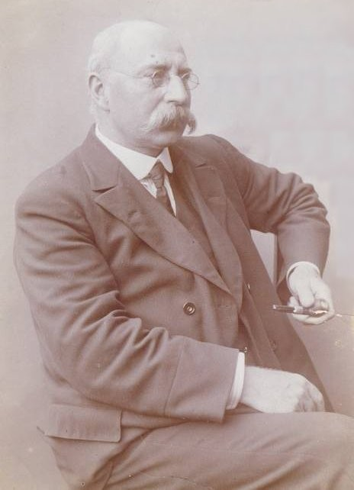

*John Isaac Plummer, in a photograph thought to have been taken around 1900 in Hong Kong.*

On his retirement from HKO, he returned to England in 1911. After a short stay at Bedford, he moved to *The Red House* in Oxshott, Surrey, where he lived with his remaining daughter and her family. The house, which still stands, is large, and it appears that he was financially comfortable in his final years. He died at *The Red House* on 07 February 1925. His death certificate recorded the cause of death as *diabetes mellitus and heart failure*. It mistakenly accorded him a status that would undoubtedly have occasioned him great delight, listing his profession as *Astronomer Royal for Hong Kong (retired)*!

# The Pretyman Family

Tomline’s heir was Captain Ernest Pretyman. Born on 13 November 1859 at Great Carlton, Lincolnshire, he was educated at Eton and the Royal Military Academy, Woolwich. He joined the Royal Artillery in 1880 and was promoted to captain in 1889, but resigned his commission when he inherited Orwell Park.

Pretyman, like Tomline, was an MP, representing Woodbridge 1895–1906 and Chelmsford 1908–23. He sat as a Conservative.

Also like Tomline, Pretyman was Commodore of the Royal Harwich Yacht Club (1921–31), but unlike his predecessor was an enthusiastic participant in the affairs of the Club, not only attending business meetings but also racing. Pretyman followed in illustrious footsteps, succeeding the future King, George V, who held the position of Commodore 1895–1910. After his accession to the throne in 1910, George V remained an enthusiastic yachtsman and patron of the Club until his death in 1936, regularly participating in regattas and the Southend to Harwich *Down Swim* race. He was a frequent visitor to Pretyman at Orwell Park.

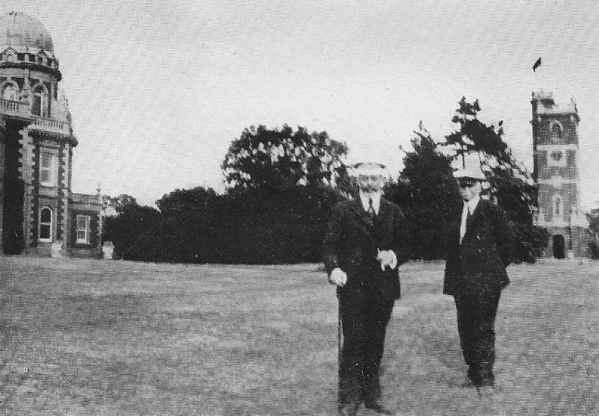

*King George V and Captain Ernest Pretyman on the lawn of Orwell Park after the “Down Swim” race in 1921.*

Pretyman was uninterested in astronomy and surviving correspondence shows that was willing to sell the sell the telescope should a buyer come forward. He made Plummer redundant shortly after he inherited Orwell Park. Although during his ownership of Orwell Park the Observatory was little used, he did occasionally call upon the services of a Mr Hancock of Nacton and a Mr Wiseman, a local schoolteacher, to entertain his visitors in the Observatory and to work the telescope to show them the night sky.

Pretyman was keenly interested in archaeology, and for a time was vice president of the Suffolk Institute of Archaeology. Pretyman Road in Ipswich is named after him.

In 1930, an amateur astronomer living in Ipswich, Edward Howard Collinson, asked Pretyman for permission to use the telescope. Pretyman granted permission, and for the next five years, Collinson used the telescope, principally to observe Mars and Jupiter. His observing notes, held in the archives of the British Astronomical Association (BAA), indicate that, at the time, the Observatory was still in a good state of repair. In 1935, Collinson purchased his own large telescope, and ceased observing at Orwell Park.

Pretyman died in 1931 and Orwell Park then passed to his eldest child, George Marcus Tomline Pretyman (1895–1979). Unfortunately, when George investigated the financial affairs of his inheritance, it rapidly became apparent that they were in very poor order. During the economic turbulence of the preceding years, Ernest had mortgaged many properties and sold land associated with the mansion, but even so found it necessary to maintain a substantial overdraft. George examined options to reduce the costs of running the estate and even considered in detail demolishing part of the mansion in order to reduce his outgoings. By the mid-1930s, he had concluded that he could no longer retain the Observatory and telescopes.

In March 1936, he corresponded with the Astronomer Royal, Harold Spencer Jones, seeking advice on selling the telescope. Jones advised that the OG of the telescope was *not a very good one* and there was little prospect of obtaining an offer even of £100 for the instrument; he advised Pretyman instead to donate the telescope to a school or other institution that could put it to use.

Pretyman then arranged for Charles Baker of London, a leading telescope supplier, to remove temporarily the OG and forward it to W H Steavenson, a leading optical expert and astronomer, for testing. Steavenson’s report, prepared in July 1936, concluded that the OG was *not one of the highest excellence…* and that *it is not capable of the most delicate work that a first class objective of its size should do..*. Baker advised that the cost of moving the Tomline Refractor to a new location might exceed the value of the instrument, and repeated Jones’s advice that the best approach might be to donate the refractor to a body such as a public school.

In November 1936, Pretyman offered the telescope to Eton College. Fortunately, the College declined the offer and, before Pretyman could devise an alternative means of disposing of the instrument, he sold Orwell Park.

# Orwell Park School And World War II

In 1936, Aldeburgh Lodge School purchased Orwell Park Mansion and the surrounding lands, relocating there in 1937 and renaming itself Orwell Park School. The headmaster at the time was Mr N H Wilkinson. He contacted Mr Hancock in Nacton and learned from him how to use the telescope. He used the instrument until 1939 to instruct the schoolboys in astronomy. They generally observed the Moon, planets, star clusters, nebulae and double stars.

In 1939, on the outbreak of the Second World War, the School moved out of Orwell Park, and the Seventh Armoured Division, the *Desert Rats*, moved in. During the War, the Observatory was used principally for fire-watching.

The Army did not care well for the Observatory! In correspondence much later, Wilkinson blamed the soldiers for *appalling damage (including considerable theft)*, amongst which he listed damage to the Observatory clock and theft of most of the eyepieces.

In 1946, the School returned to Orwell Park, and Wilkinson resumed using the telescope. He purchased new eyepieces and had the OG taken out and cleaned by a firm in London. The lift was deemed unsafe at this time, and was no longer used.

# Ipswich And District Astronomy Society (IDAS)

On 09 October 1948, 25 members of Ipswich and District Natural History Society (IDNHS) visited Orwell Park Observatory. Roland Clarkson[8], a prominent amateur astronomer living in Felixstowe, led the visit. They observed Jupiter, its Galilean satellites, the Moon, star clusters and a double star. The visitors were so impressed with the facility that Clarkson requested the committee of IDNHS to create an Astronomy Section, which was duly constituted at the next AGM on 15 January 1949.

The Astronomy Section thrived and, in 1950, following a ballot of the membership, separated from IDNHS, re-forming as a separate entity, Ipswich and District Astronomy Society (IDAS). Clarkson was elected first president of IDAS, Mr D J Fulcher Secretary and Mr A W Goodwin Chairman. Their newsletter, *The Stargazer*, was published (almost!) monthly.

IDAS occasionally used Orwell Park Observatory, but its primary activities were talks - held in the Museum Lecture Room in High Street, Ipswich - and constructing telescopes, rather than observing. The Society often held committee meetings in members’ homes.

Members of IDAS undertook limited repairs to the Observatory, but during this time the fabric of the Observatory further deteriorated.

In 1957, IDAS folded after Mr C Munford, its then Secretary, left the area and the Society was unable to attract a replacement. Thereafter, again the Observatory was unused.

# Orwell Astronomical Society, Ipswich (OASI)

Details of the formation of OASI are lost in the mists of history! Unfortunately, organisation of the Society was largely informal in its early years and no written records have survived prior to 1972. However, correspondence between Mr M J Allen (first Secretary of OASI) and Roy Gooding (current Secretary) in the early 1980s has shed a little light on matters. Allen indicated that OASI began to form in 1966–67 when he, together with some school friends, approached Orwell Park School to ask for permission to use the refracting telescope and restore the facility.

## Renovation Of The Observatory

In 1969 or 1970, the Anglia Television *Bygones* programme filmed a short report about the Observatory*[9]*. The report revealed that, after years of neglect, the Observatory had fallen into a very serious state of disrepair. The wall between the stairwell and the transit chamber was crumbling and the telescope mount rusting. Doors were missing from the equatorial room into the stairwell and the transit chamber.

Major restoration commenced during the early 1970's. A full-page report in the *Evening Star* in June 1971 publicised OASI, the Observatory and the Society’s ambitious plans for renovations.

Thereafter, every summer for more than a decade the Observatory was closed for repair work. Initially, the wall of the equatorial room was so badly affected by damp that the paint peeled off every winter and it was necessary to repaint every summer! Eventually, repairs to guttering cured the dampness and nowadays, such frequent repainting is not required. At this time, members of OASI also repaired the floor, re-pointed the exterior walls, re-plastered the interior walls and rewired the building.

Two wheels at the bottom of the dome shutter run in a track mounted tangentially to the iron ring at the base of the dome. Three L-shaped iron brackets secured the track to the iron ring. Bolts fixing the track to the brackets had been scraping lead from the roof of the transit chamber as the dome rotated, and it had become a priority to raise the track and brackets so as to prevent further damage. Unfortunately, while attempting this task, two of the three brackets snapped, rendering the shutter immobile. The brackets were eventually replaced with steel versions to a new design giving a stronger support than the original and avoiding further damage to the lead roof.

In the 1970s and 1980s, the shutter of the dome acted in a small way as a refuge for wildlife! Starlings nesting inside the shutter were the cause of a considerable mess on the floor in the early years. A repair to a hole in the shutter ended this problem. Later, in the summer of 1983, the floor was found to be constantly littered with dead and dying bees. Investigations revealed that a colony of bees had moved into the shutter. During January 1984, members of OASI dismantled some of the mahogany lining from the shutter and a local beekeeper removed the bees together with a large quantity of honeycomb. The only remaining evidence of the episode nowadays is saw marks in the mahogany lining at the top of the shutter[10].

In the summer of 1986, Orwell Park School, as part of a programme of refurbishment of all the roofs of the School, re-leaded the flat roofs of the transit chamber, lift shaft and stairwell. During the operation, workers placed a roll of lead on the iron ring at the base of the dome aperture and, unfortunately, the weight of the metal caused the ring to fracture. Fortuitously, the split was on the right hand side of the aperture, which is one of the easiest places for removing the mahogany lining to access the iron framework of the dome, and OASI was able to undertake a comprehensive repair. A three metre length of strip steel was bent to the appropriate radius and bolted over the fracture along the inside edge of the iron ring. A new bracket was fitted to secure the dome rib nearest the fracture to the iron ring. Two new steel brackets were added to secure the lower shutter rail to the iron ring.

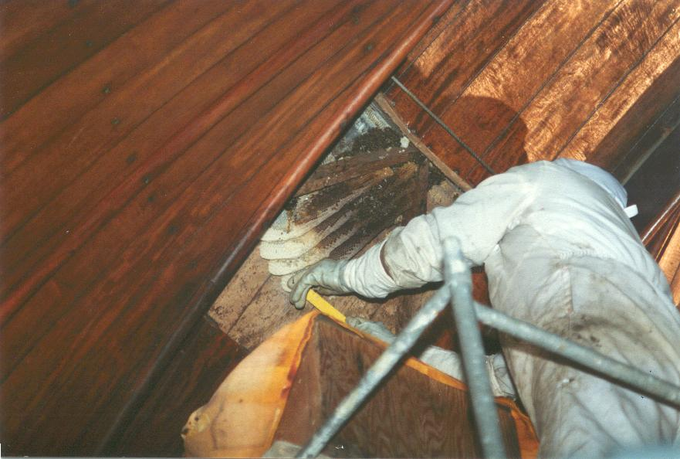

*Removing the bee colony from the shutter, January 1984.*

For many years, the roof of the transit chamber had leaked badly, making work inside the room impossible. The new lead roof immediately remedied the situation, finally creating an opportunity to renovate the chamber. This catalysed an enormous amount of work during the period 1987–90, with many projects undertaken:

* Several broken windows in the stairwell and belvedere were repaired.
* More walls were re-plastered and the entire Observatory Tower was repainted with several coats of paint.
* The transit chamber was comprehensively renovated. The tops of the concrete piers were recast and the bearings for the transit telescope repaired. The side walls of the roof aperture were rebuilt, the shutter repaired and re-hung, and the rack-and-pinion mechanism for opening the shutter rebuilt. The floor of the chamber was removed and a new floor laid 30cm lower, in line with the original level. This necessitated construction of a new set of steps from the equatorial room down into the transit chamber. Finally, a sidereal clock and barograph were installed.
* In the equatorial room, two wheel boxes that did not properly support the dome were removed and re-positioned; the shaft of the large wheel for rotating the dome was replaced and the floor made more secure with additional brick supports. Additionally, the observer’s chair and original clockwork drive of the Tomline Refractor were renovated.
* A floor was installed in the lift shaft off the equatorial room to create a space for storing eyepieces, star charts, etc.

The installation of the floor in the lift shaft was a great success and, in the early 1990s, in order to create yet more storage space, OASI repeated the exercise, this time off the belvedere. Unfortunately, for ease of construction, the level of the new floor was set approximately 30cm above the floor in the belvedere. Following this, relatively little maintenance and renovation was undertaken until 2001.

OASI began two major renovation projects in 2001. Ever hungry for yet more storage space, members installed a third floor in the lift shaft, this time at the base of the Observatory Tower. The project proceeded smoothly and was soon complete. The second project, which was much more ambitious, addressed the creation of a new library for OASI.

Royston Cheesman instituted the OASI Library in early 1972, after Edward Collinson and staff at Orwell Park School donated books, slides and magazines. OASI appointed Tom Cardot its first Librarian in April 1974. He collected material and polled members of OASI for their interests in astronomical publications. The library grew gradually over the years as members donated material and librarians made occasional purchases. In the mid-1980s, the Committee obtained a large glass-fronted bookcase to house the library collection. Initially, the bookcase was sited in the belvedere, but once the floor was installed in the lift shaft off the belvedere, it was relocated there. By the late 1990s, the amount of library material considerably exceeded the capacity of the bookcase and, unfortunately, the bookcase itself had proved far from ideal and its location in the converted lift shaft was very dusty and damp. A new solution clearly was required!

After considerable discussion the Committee of OASI adopted an ambitious scheme to convert the space in the lift shaft off the belvedere into a custom designed library with a mezzanine area above for general storage. The plan called for the floor to be removed and re-laid at the same level as the floor in the belvedere (thus correcting the short-cut taken during its installation), the walls to be dry-lined with insulation and plasterboard, custom-designed bookcases to be installed and the facility to be fitted with good lighting and ample electric sockets. Unfortunately, at the time, nobody appreciated the full scale of the project! Work started in late 2001 and continued for the next two years. Although the project proved much more labour intensive than anticipated, the end results were a fitting tribute to the hard work of all concerned. Through Ken Goward’s contacts in the Society for the History of Astronomy, Peter Hingley, librarian of the Royal Astronomical Society, formally opened the library at a ceremony on 15 May 2004.

Following completion of the library, little renovation work has been undertaken. However, it has become increasingly apparent that the fabric of the Observatory Tower itself has become seriously damaged through general neglect and the ravages of time. A professional survey of the building in May 2004 revealed many areas in urgent need of attention, and a further survey in February 2010 estimated the cost of stabilising the condition of the building as £500,000. Sums such as this are far beyond the realm of OASI to deal with alone, and at the time of writing the Society is in discussion with the management of Orwell Park School, professional astronomers and others about the best way to address the situation.

## Open Days

In 1972, OASI held its first Open Day. The event was originally scheduled for 28 May of that year but, due to persistent problems with the shutter of the dome necessitating repairs throughout the summer months, had to be postponed to 30 September. At the time, the event was thought to mark the centenary of opening the Observatory; however, subsequent research has established that it was premature by two years. The event was a great success, attended by an estimated 200 visitors. In the afternoon, there was an astronomical film show and various members’ exhibits; a clear sky enabled solar observing to be demonstrated. Luckily, the sky remained clear all evening and, on the School playing field, members of OASI showed visitors the most prominent constellations of late summer. The Tomline Refractor was in constant use all evening until approximately 1.00am. Although none of the visitors knew it at the time, due to a lack of funds to progress the renovations, a car jack and a stack of loose bricks supported the Observatory floor! Fortunately, the monies raised during the day helped to place OASI on a sound financial footing that enabled it to press ahead with the renovations.

After the success of the first Open Day, the Committee of OASI decided to schedule them approximately annually. (Occasionally, additional Open Days are arranged when there are especially interesting objects on view.) During the period 1972-2010, some 7500 visitors attended Open Days. (This figure is approximate: accurate counts of attendance were not taken at some events.) Particularly memorable Open Days are as follows:

* Open Days on 13–16 November 1985, 11–15 December 1985 and 25–26 April 1986 to observe Halley’s Comet attracted huge numbers of visitors, some of whom had to wait for up to two hours for their brief turn at the eyepiece of the Tomline Refractor! OASI issued a certificate to every visitor who saw the comet through the telescope.
* On 16 July 1988, OASI hosted a Convention and Open Day marking the 21st anniversary of the Society. The event culminated in the ceremonial cutting, by Chairman Dave Payne, of a 21st anniversary cake!
* The 1994 Open Weekend was scheduled to coincide with a visit by Britain’s first astronaut, Helen Sharman, to Orwell Park School on 14–16 October of that year. Helen was visiting because members of the Orwell Park Radio Club had spoken to her by radio while she was orbiting the Earth aboard the Russian space station Mir. Despite a completely overcast sky, many visitors attended and several joined the Society.
* OASI opened Orwell Park Observatory to enable members of the public to observe the two naked-eye comets which passed through the inner solar system in the mid-1990s. The Observatory was open 23–25 March 1996 for Comet Hyakutake and 11–14 April 1997 for Comet Hale-Bopp. Unfortunately, clouds all but prevented observation of Hyakutake. However, skies were clear for Hale-Bopp and again the Observatory was packed with visitors, in scenes reminiscent of the Comet Halley Open Days more than a decade earlier. This time, however, no certificates were issued to the visitors!
* Members of OASI put considerable effort into the Open Days 07–08 October 2000 which were held to mark the new Millennium. As always, the Tomline Refractor was in use; additionally there were displays of members’ projects and telescopes. A small sample of Moon rock, borrowed from NASA, proved to be a great attraction. The 2000 event set the measure of Open Days for subsequent years.
* The 24–25 March 2007 Open Days marked the 40th anniversary of OASI. Although the weather was not good, and accordingly the number of visitors small, this had the benefit that members of OASI could spend more time with each. All who attended agreed that the event was a great success.

## Organisation And Members

In 1972, OASI held its first recorded AGM, at which it decided to organise itself broadly along similar lines to the BAA, with several Observing Sections concentrating on particular areas of interest (e.g. Planets, Lunar, Deep Sky Objects) meeting at the Observatory on different nights of the week. This model of organisation was gradually abandoned and nowadays there are no formal Observing Sections as such.

In February 1972, OASI started publishing a monthly newsletter for its members. *The Newsletter* generally contains news about Society activities and reports of observations and other projects. To date, OASI’s publication record is unbroken: no editions have been missed! Early editions of *The Newsletter* provide some insight into the formation of OASI. In particular, the first edition indicates that the initial recorded membership of OASI numbered 13 individuals.

## Chairmen

To date (2011), members of OASI have elected eight chairmen:

|  |  |
| --- | --- |
| John Easty | *circa* 1967–72 |
| Royston Cheesman | 1973–80 |
| Dave Payne | 1981–2002 |
| Ken Goward, FRAS | 2003–08 |
| Neil Morley | 2009–13 |
| David Murton | 2014–17 |
| Paul Whiting, FRAS | 2018 |
| Andy Gibbs | 2019 to date |

Each chairman brought his own interests and aptitudes to the role. John Easty steered OASI through the initial formation and organisation of the Society. Royston Cheesman oversaw much of the early work to renovate the Observatory and introduced a lecture programme and field observing trips. Dave Payne, an observer of considerable ability, fostered observing and the use of the Tomline Refractor; under his chairmanship, a programme of training in the use of Tomline Refractor was instituted. Ken Goward was much interested in the historical aspects of astronomy, and through a network of contacts with leading historians of the science did much to raise the profile of OASI at a national level. Neil Morley was greatly concerned by the decay to the fabric of the Observatory and worked with Orwell Park School to try to find a solution to the problem. David Murton placed great emphasis on outreach activities and encouraged members of OASI to support events enabling public participation in astronomy. Paul Whiting, FRAS, accepted the role of chairman in a caretaker capacity pending identification of someone willing to take on the role on a long-term basis. Andy Gibbs promotes observing and further efforts with Orwell Park School to try to find a solution to arrest the decay in the fabric of the Observatory.

## Tomline Refractor

In May 1973, members of OASI removed the 26cm OG of the Tomline Refractor and transported it by car to Horace Dall of Luton, the leading optical expert in the UK. Dall cleaned the lens and then tested it. He found it to be badly over-corrected for spherical aberration, and he went on to correct the error by refiguring the lens. As a result, the performance of the instrument, particularly when used with modern eyepieces, is better nowadays than it was in Tomline’s era.

The OG generally requires cleaning every few years. It is prone to the growth of a fungus in the space in the interior of the doublet between the optical surfaces of the inner and outer lenses. Removal of the fungus requires the glasses of the lens to be removed from the lens cell and each optical surface individually cleaned.

Until 2001, the instrument was known simply as the “big telescope”. In that year, Dr Allan Chapman, leading historian of astronomy, graciously accepted a request to become Honorary President of OASI and dedicated the instrument the *Tomline Refractor* after his inauguration at a ceremony in the equatorial room.

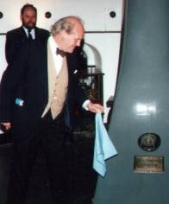

*Dr Allan Chapman unveiling the name plaque on the Tomline Refractor in 2001.*

## Observations

Over the years, members of OASI have reported countless observations of all sorts of astronomical phenomena. Some of the most noteworthy are as follows:

* A Transient Lunar Phenomenon (TLP) is any strange flash, glow or obscuration, lasting for seconds, minutes or perhaps hours, on the lunar surface. In the mid-1970s there was much interest in the phenomenon, and on the night of 18–19 June 1975, Royston Cheesman and Dave Barnard, observing with the Tomline Refractor, saw what they thought was a TLP near the crater Clavius. Unfortunately, after correspondence with Patrick Moore, the observers concluded that the effect had been caused by a depression in the lunar surface viewed at a particular angle of illumination.
* Alan Smith operated a fireball camera on every clear night during the 1980s to record the tracks of bright meteors through the heavens. In 1983, on the evenings of 15–16 March and 09–10 April, the camera recorded anomalous bright objects. Neither the British Meteor Society nor the Data Anomaly Research Center in Maryland, USA was able to offer any explanation for the images, which, to this day, remain unexplained.
* On the evening of 03–04 May 1989, Dave Payne led observers using the Tomline Refractor in trying to observe all nine planets[11] of the solar system during a single evening. Although the observers were unsuccessful, the following evening Dave tried again at home, and this time succeeded!
* During the period 1992–2002, James Appleton, Martin Cook and Alan Smith encouraged interest in observing and timing lunar occultations. During the 11 years, observers amassed 241 observations. James analysed the observing data to estimate a minute random variability in the angular velocity of rotation of the Earth, eventually producing an estimate in excellent agreement with the “official” value published by the BAA.
* On 07 May 2003, a transit of Mercury took place; that is, Mercury passed between the Earth and the Sun and was visible in silhouette against the solar disk. Many members of OASI observed the phenomenon at Orwell Park and elsewhere, gathering a wealth of interesting observational data. The event acted as a practice run for the transit of Venus the following year.
* On 08 June 2004, the long-awaited transit of Venus took place. (The last had occurred on 06 December 1882.) Members of OASI stationed at Orwell Park Observatory and elsewhere in the UK and overseas used a variety of instruments to observe the phenomenon. Thanks to experience gained during the transit of Mercury in 2003, observers using the Tomline Refractor had made major improvements to equipment and operational procedures. The refractor was used to project an image of the Sun and Venus onto a white card held behind the eyepiece; the image had a diameter of almost half a metre, making it the largest known in the UK of the transit. All the observers reported a highly successful and very enjoyable experience under near-perfect skies. The observing reports of members of OASI were collated into a booklet and presented by Ken Goward as a gift to Sir Patrick Moore.

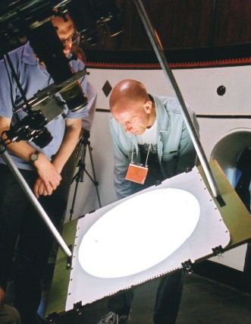

*Members of OASI using the Tomline Refractor to observe the transit of Venus on 08 June 2004.*

## Other Activities

Throughout its existence, OASI has devoted considerable time and effort to hosting visits by local groups and individuals to Orwell Park Observatory. During the period 1972-2010, OASI welcomed 556 visiting groups and many thousands of visitors to the Observatory. Particularly notable visitors include Sir Patrick Moore, Helen Sharman, the first British astronaut, John Dobson, inventor of the “Dobsonian” telescope mount, and several current and past presidents of the British Astronomical Association

Royston Cheesman instituted OASI’s lecture programme. The first lecture, which was entitled *The Hertzsprung-Russell Diagram*, was given by George Curtiss on 05 October 1973. The Society generally organises a handful of lectures during each winter season. Lecturers have included Sir Patrick Moore and other professional astronomers, presidents and section heads of the BAA, historians and members of OASI.

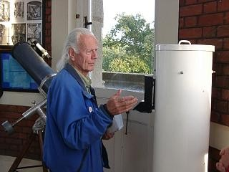

*John Dobson inspecting the “Dobsonian” telescope constructed by members of OASI.*

In September 1998, Ted Sampson began a programme of informal astronomy workshops. These have run every winter season since, and covered a variety of topics including observing, instrumentation, image processing, space travel, cosmology and the history of astronomy.

Over the years, several members of OASI have undertaken telescope making projects, both as individuals acting alone and as organised Society activities. These culminated in February 1999 with a decision by the Committee of OASI to fund a project to construct a 48cm Dobsonian reflector, named the *Millennium Telescope*, to mark the year 2000. As with many activities to mark the Millennium, the project turned out to be more ambitious than originally expected, and it was not until 18 April 2005 that the instrument saw first light.

# The Future of Orwell Park Observatory

OASI is keen to maximise the use of the Observatory and to encourage wide public interest in the fascinating science of astronomy. Key to these aims is fostering interest in the next generation of potential astronomers, namely the children at Orwell Park School and other schools in the neighbourhood. OASI is in discussion with the personnel of Orwell Park School over how best to work with schools in the region to utilise the Observatory and harness the enthusiasm of members of OASI, under the supervision of school staff, to support a variety of astronomy projects with young people.

Orwell Park Observatory is unique in the UK in terms of its facilities and heritage. Unfortunately, despite the efforts of OASI to prevent further deterioration in the fabric of the building, the ravages of history are inexorably taking a toll. Decades of neglect of the infrastructure means that it is now in such bad condition in some areas that professional intervention is urgently required. A survey in early 2010 estimated the cost of arresting the decline as £500,000 and of a full restoration as several £million. OASI and Orwell Park School are working together to agree an approach to raise funds for this essential project.

History has a habit of repeating itself, and of course, it may be that a philanthropist like Tomline comes once more to the rescue of the Observatory, thus closing the circle of history of the first (almost) one and a half centuries of the facility!

-o0o-

# References

Airy, W., *The Orwell Park Observatory*, Engineering, pp. 257-259, 02 October 1874.

Anderson, J. M., *The Orwell Park Observatory*, Transactions of the Royal Institution of British Architects, pp. 15-26, 1875.

BAA, *The British Astronomical Association - The Second Fifty Years*, third edition, January 2011.

Dixon, D., *The King’s Sailing Master*, G G Harrap & Co Ltd, 1948.

*East Anglian Daily Times*, Obituary of Colonel Tomline, 26 August 1889.

*East Anglian Daily Times*, Obituary of Roland Clarkson, 18 February 1954.

Ford, D., *Admiral Vernon in the Navy*, 1907.

*Ipswich Evening Star*, Obituary of Roland Clarkson, 18 February 1954.

Kost, J., *Wissenschaftlicher Instrumentenbau der Firma Merz in München (1838-1932)*, 2014. Dissertation zur Erlangung des Doktorgrades an der Fakultät für Mathematik, Informatik und Naturwissenschaften, Fachbereich Geowissenschaften der Universität Hamburg. See <https://ediss.sub.uni-hamburg.de/bitstream/ediss/5850/1/Dissertation.pdf>

Manning, C. A., *Suffolk Celebrities*, published by McCorquodale & Co. Ltd, 1893.

OASI Newsletters.

Pike, W. T., *Norfolk & Suffolk In East Anglia, Contemporary Biographies*, 1911.

Seidelmann, P. Kenneth, (Ed.), *Explanatory Supplement to the Astronomical Almanac*, University Science Books, 1992.

*Edward Vernon 1684–1757* in *The Compact Edition of the Dictionary of National Biography* volume ll, OUP, 1975.

*The Ipswich Journal*, Obituary of Colonel Tomline, 30 August 1889.

*The Lincolnshire Chronicle*, Obituary of Colonel Tomline, 30 August 1889.

*The Times*, various articles and letters concerning Colonel Tomline, 1813–90.

Web site of the National Museum of the Royal Navy: http://www.royalnavalmuseum.org/info_sheets_edward_vernon.htm

*Whites Directory Suffolk* 1874 and 1889.

http://www.wikipedia.org

# Document History

|  |  |  |
| --- | --- | --- |
| **Version** | **Date** | **Authors** |
| Issue 1 | 1979 | D A Barnard, R M Cheesman, R E Gooding, C F Radley |
| Issue 2 | May 1990 | G Marriott, A J Smith |
| Issue 3 | 1994 | R E Gooding, P R Richards |
| Issue 4 | 1998 | R E Gooding, P R Richards |
| Issue 5 | 30 April 2011 | J M Appleton, with contributions from D A Barnard, R M Cheesman, M P Cook, R E Gooding, K J Goward, T Hammond, G Marriott, C F Radley & P J Whiting. |
| Issue 6 | 07 May 2011 | J M Appleton |
| Issue 7 | 22 June 2025 | J M Appleton |

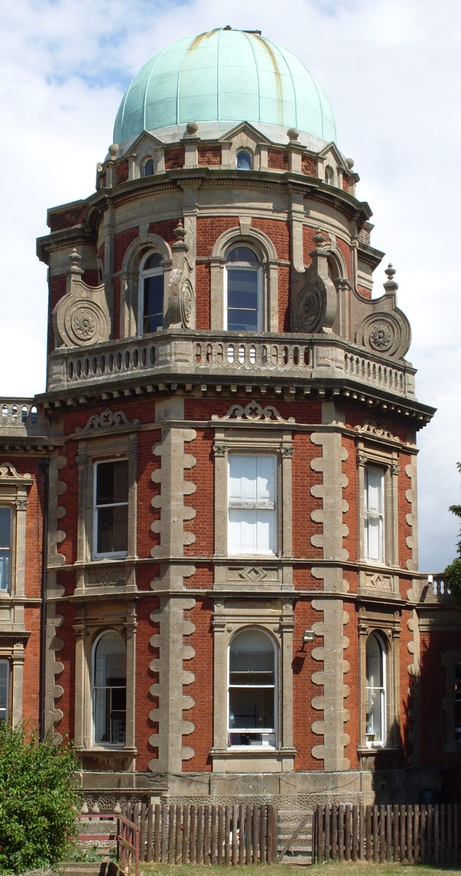

1. In 1858, Thomas Carlyle coined the unusual name of the conflict. It refers to Robert Jenkins, captain of a British merchant ship, who lost an ear in a conflict with Spanish coastguards in 1731. In 1738, Jenkins exhibited the severed ear to a committee of the House of Commons and, the following year, Britain declared war on Spain.
2. The dome originally sat on 12 wheels. When Tomline had a hydraulic lift installed at the Observatory, it was necessary to move one of the original wheels and install an additional one.
3. In 2005, Paul Whiting researched the ranking of Tomline’s telescope among the largest in the world.
4. Right ascension and declination define the celestial coordinates used by astronomers. They are analogous to the terrestrial longitude and latitude coordinate system.
5. The 1889 Ordnance Survey map of Nacton shows the Observatory within 0.4" of the position accepted nowadays, corresponding to a discrepancy of only 13m circumferential distance on the Earth’s surface.
6. A lunar occultation occurs when the Moon passes in front of a star or other body.
7. The zodiacal light is a faint glow visible, especially at tropical latitudes, on clear moonless nights in the west after sunset and in the east before sunrise. It is caused by dust in the inner solar system scattering sunlight.
8. Clarkson was a prolific lunar observer. In 1954, a 33 km diameter crater - easily visible with a small telescope - was named in his honour. However, when the International Astronomical Union rationalised lunar nomenclature in 1972, the crater was renamed Gassendi A.
9. Anglia TV later presented Orwell Park School with the 16mm film reel of the programme. It has been digitised and is available to members of OASI as a .AVI file.
10. The incident featured in the OASI *Newsletter* of February 1984 in a humorous article entitled *Search for the Beehive*. (This is an in-joke amongst astronomers, who would usually interpret *beehive* as a reference to The Beehive star cluster, M44.)
11. When the observation was made, the solar system was considered to contain nine planets including Pluto. International Astronomical Union resolutions B5 and B6 in 2006 subsequently re-categorised Pluto as a dwarf planet.